Government Dau Kalyan Arts & Commerce Postgraduate College, Baloda Bazar, Chhattisgarh

Human Values and Professional Ethics
7.1.9 Sensitization of students and employees of the Institution of the constitutional obligation: values, rights, duties, responsibilities of citizens.
In Government Dau Kalyan Arts & Commerce Postgraduate College most important emphasise is given to human values and professional ethics. So, first of all the golden words of the preamble of our Constitution is framed on wall of the institution, with an aim to bring JUSTICE, LIBERTY, EQUALITY, FRATERNITY, UNITY OF NATION among the students and employees. National anthem is also framed on the wall of the institution. National Song, State song, and Swami Vivekananda quotes are framed on the wall of the institution.
Constitution of India provides 11 important duties to its citizens which are known as the Fundamental Duties of the citizen to make the students and employees aware of their fundamental duties. Fundamental duties are also framed on the wall of the institution. For understanding the importance of Constitution every year on 26th November Constitution day is celebrated in the college which is organized by the Law department. Anti-Ragging Act is framed on the wall of the institution so, that students can understand the evil and legal affect of ragging. Employee’s code of conduct is strictly followed by our institution. NCC, NSS and Red Cross are available for the students to boost up the national values among themselves and come forward to serve the nation.
Preamble of Indian Constitution and National Anthem

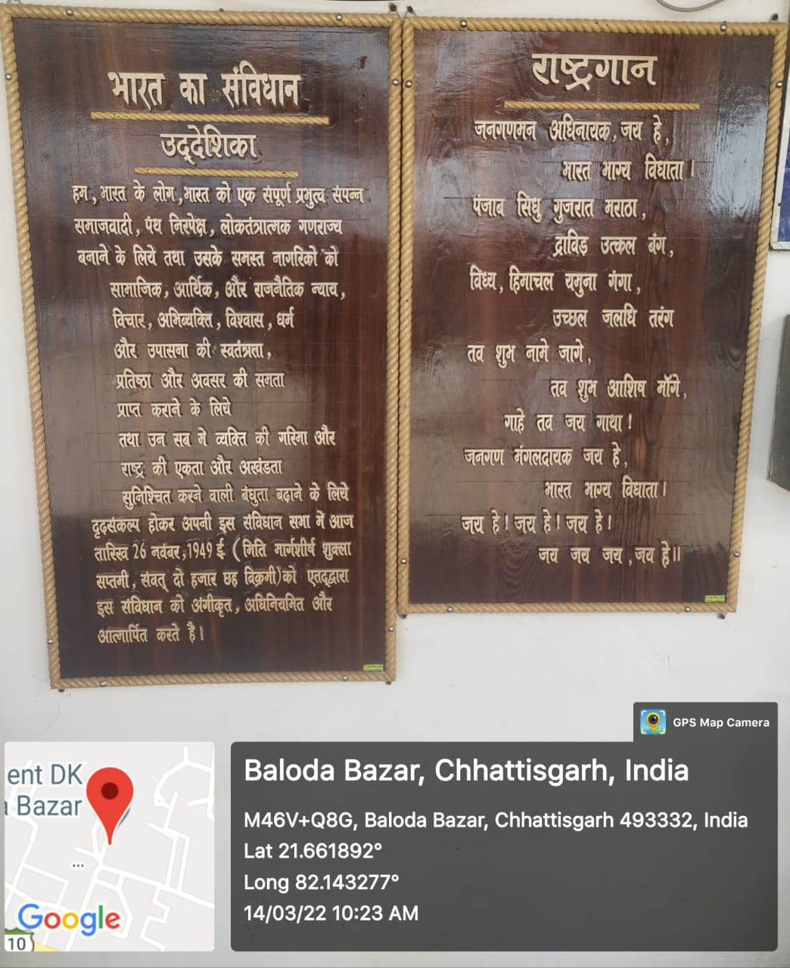
National Song

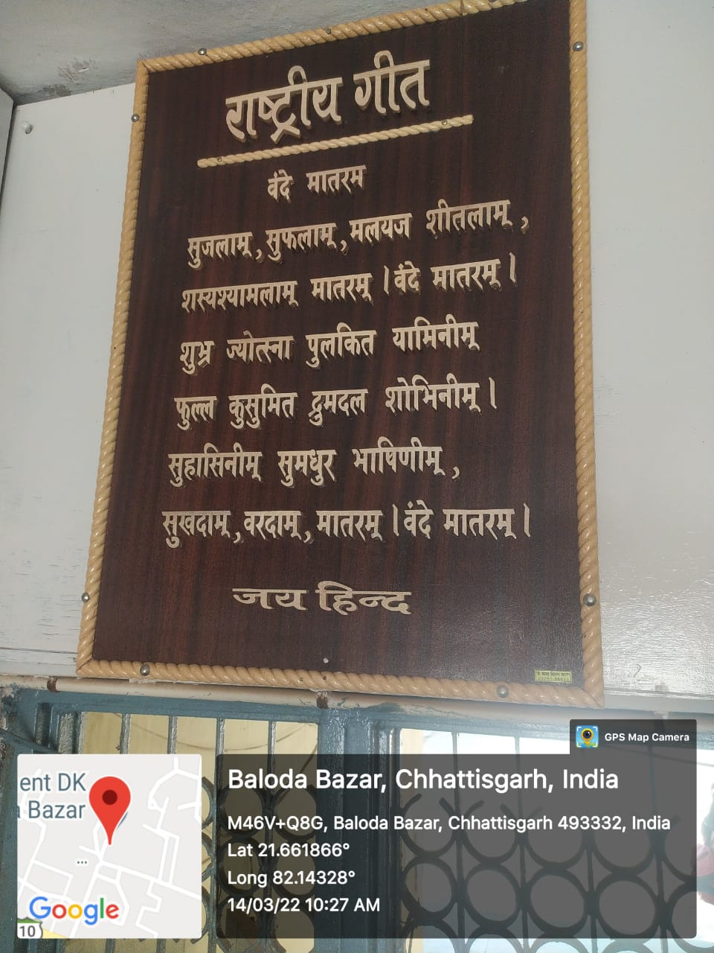
State Song

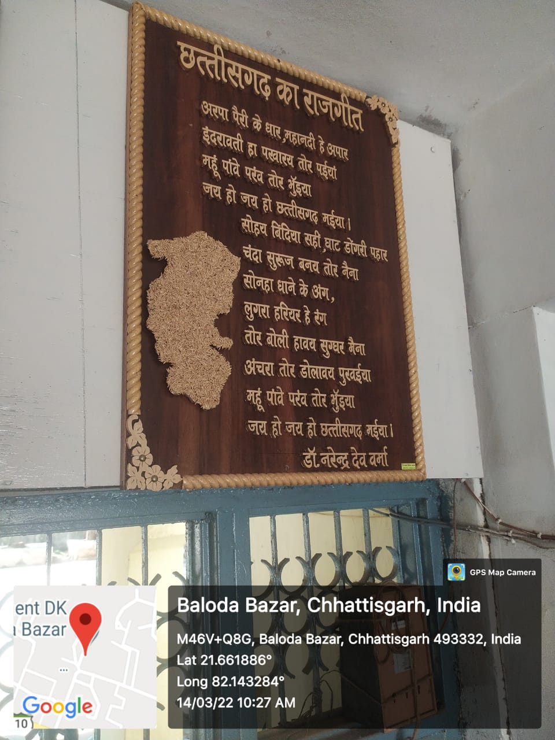

Fundamental Duties

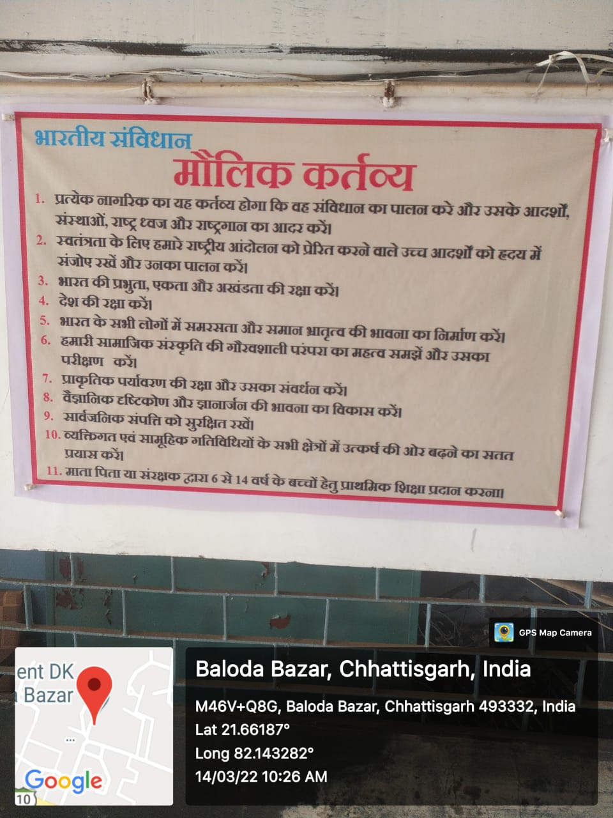
Anti-ragging Act

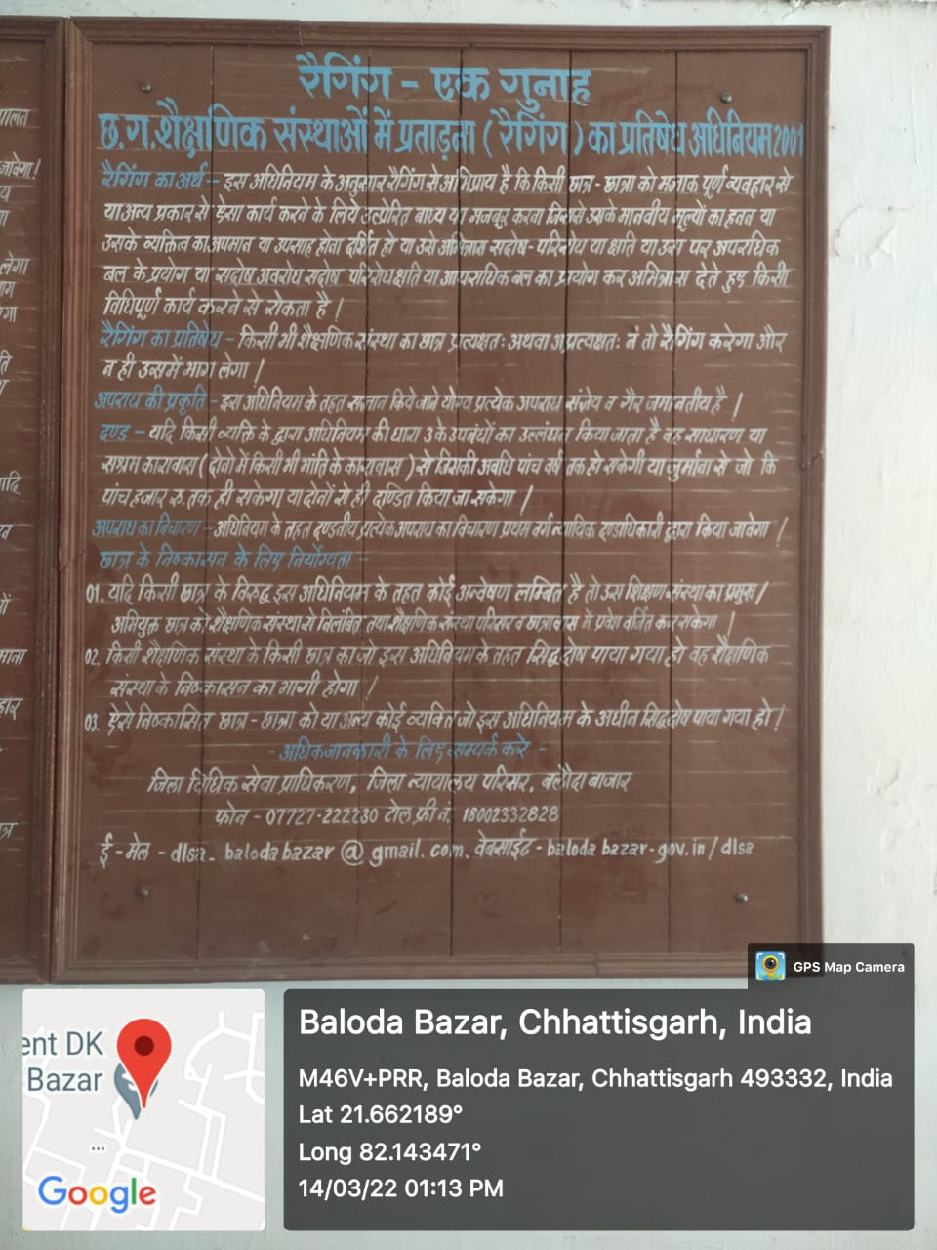

Swami Vivekananda’s quotes
